**Q1.**

**Step 1: After logging into AWS account select EC2 service to create the instance**

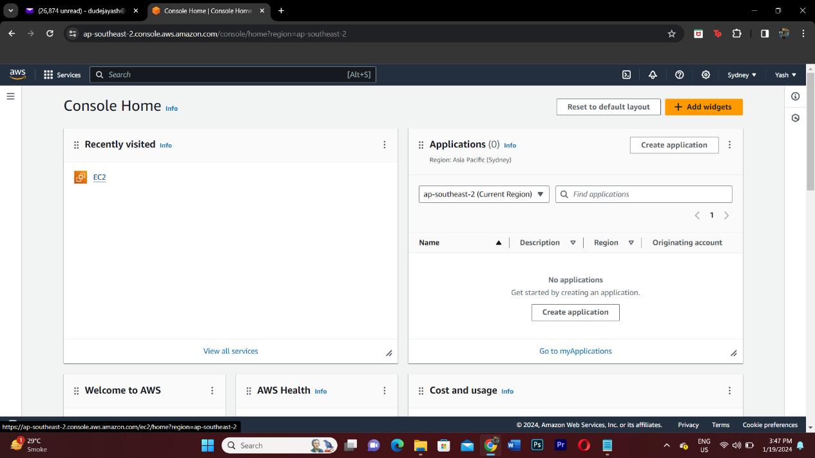

**Step 2: Creating an instance**

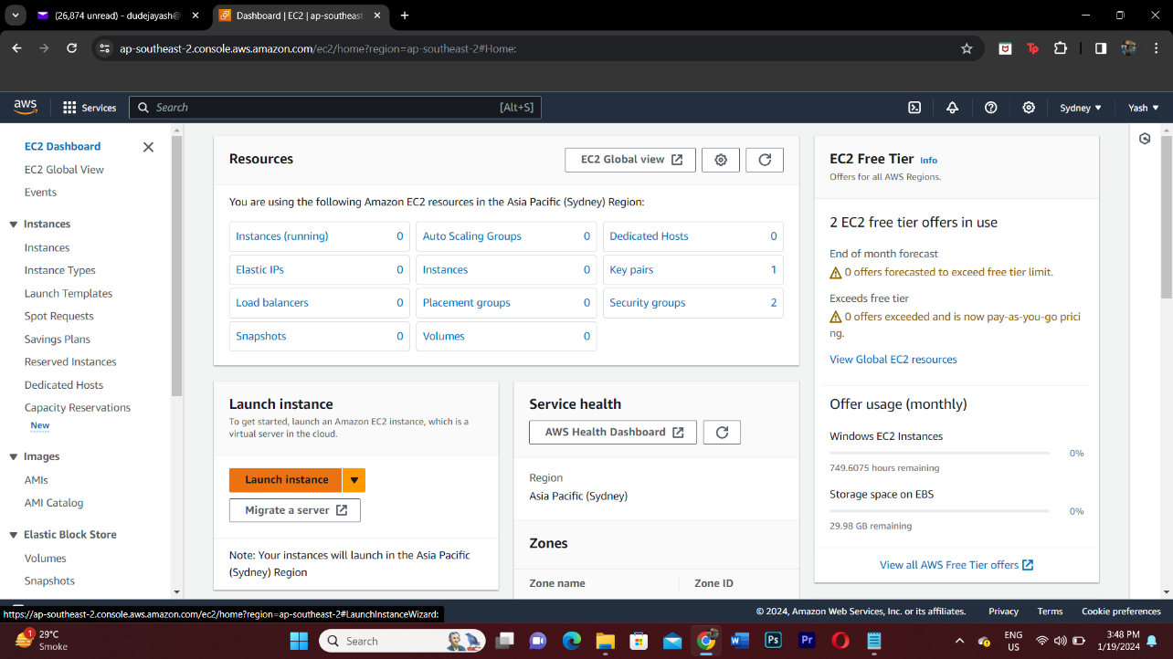

**Step 3: Name of the server**

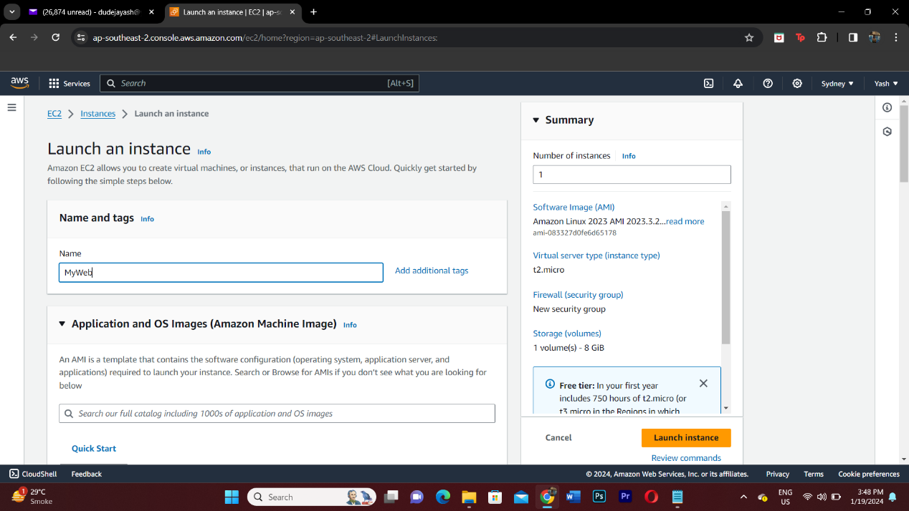

**Step 3: Select the application/OS you want to use**

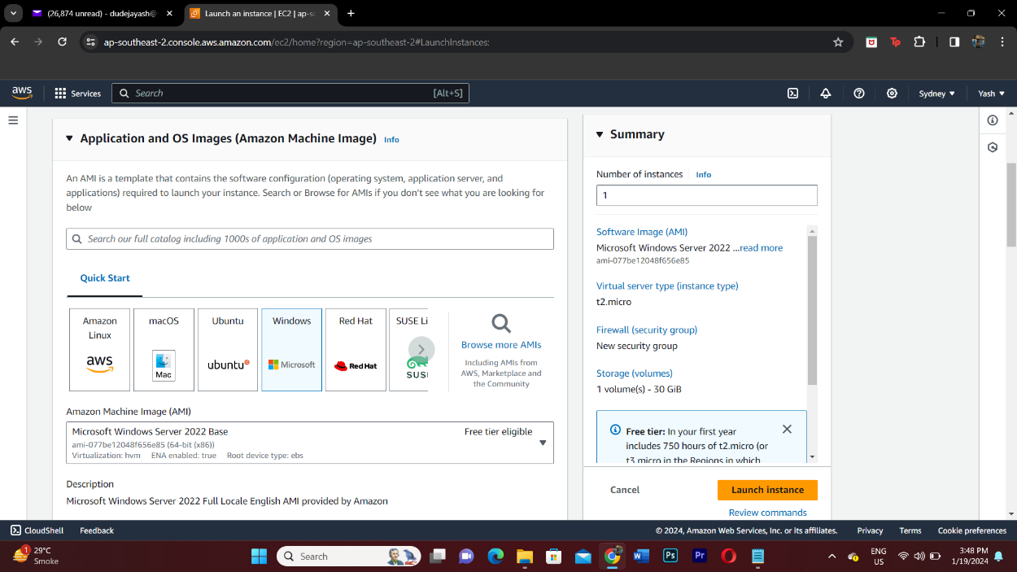

**Step 5: Create a new key pair value**

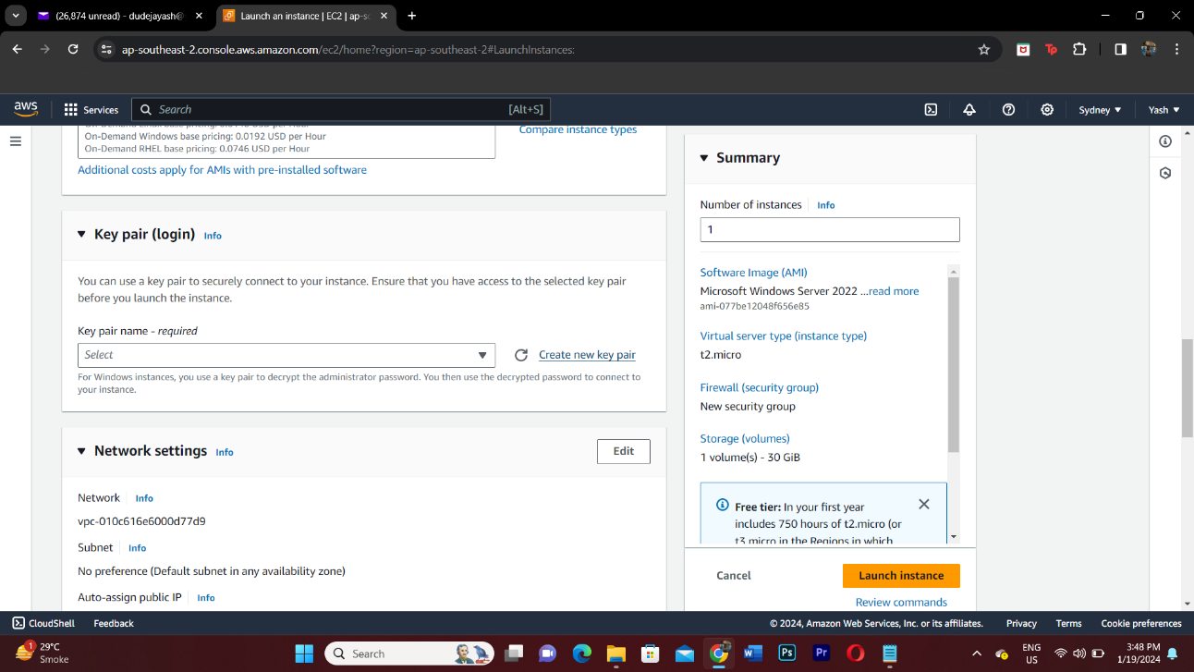

**Step 6: Name the key pair value and the file format**

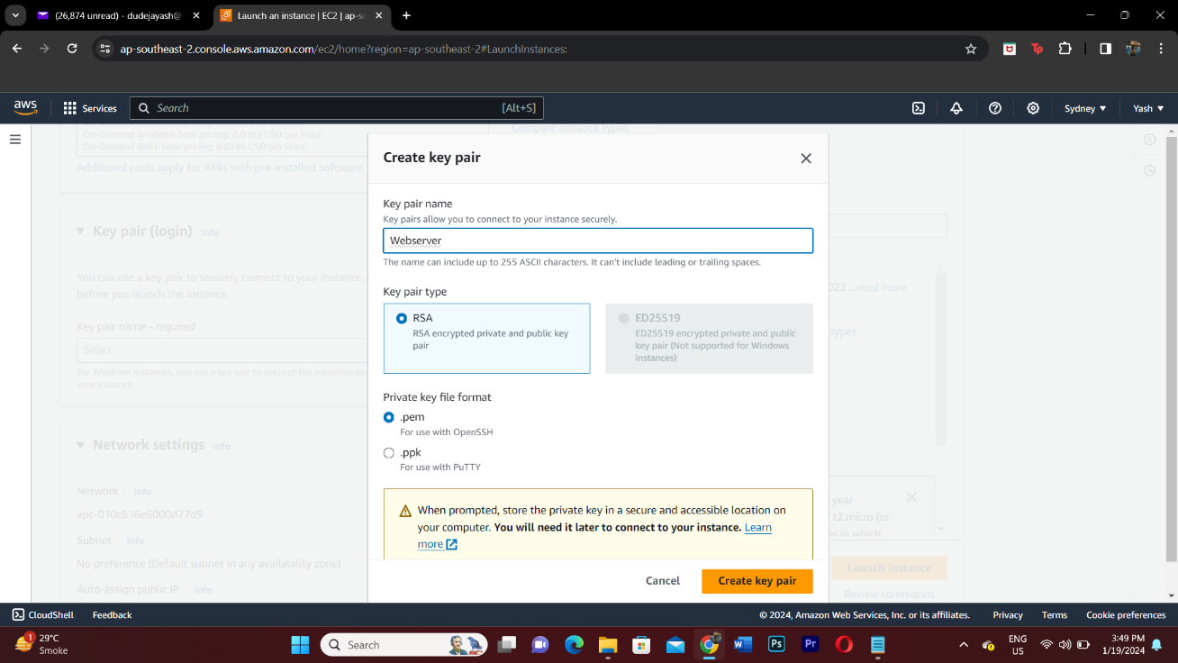

**Step 7: Configure the storage you want for your system**

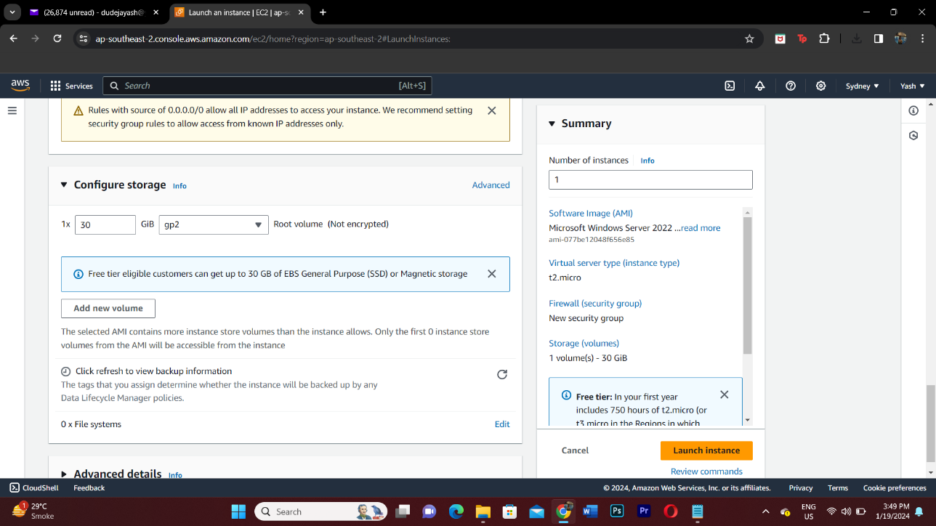

**Step 8: Launch the instance**

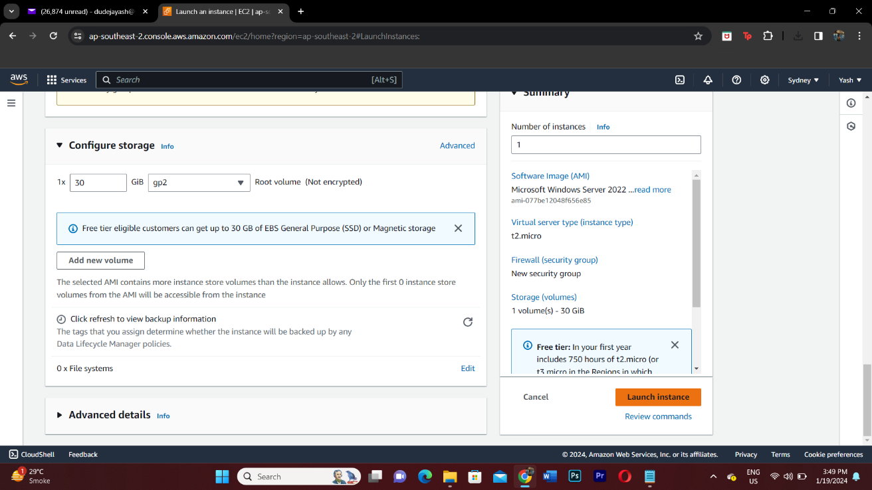

**Step 9: Instance is being created**

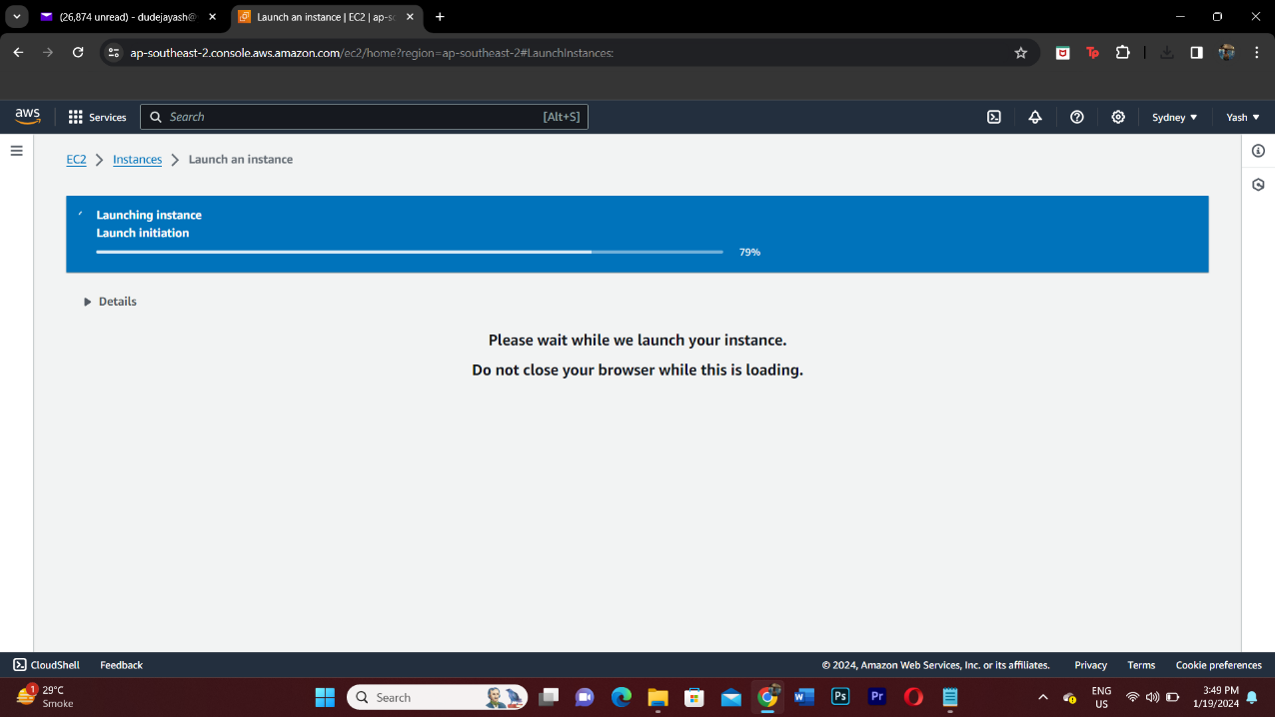

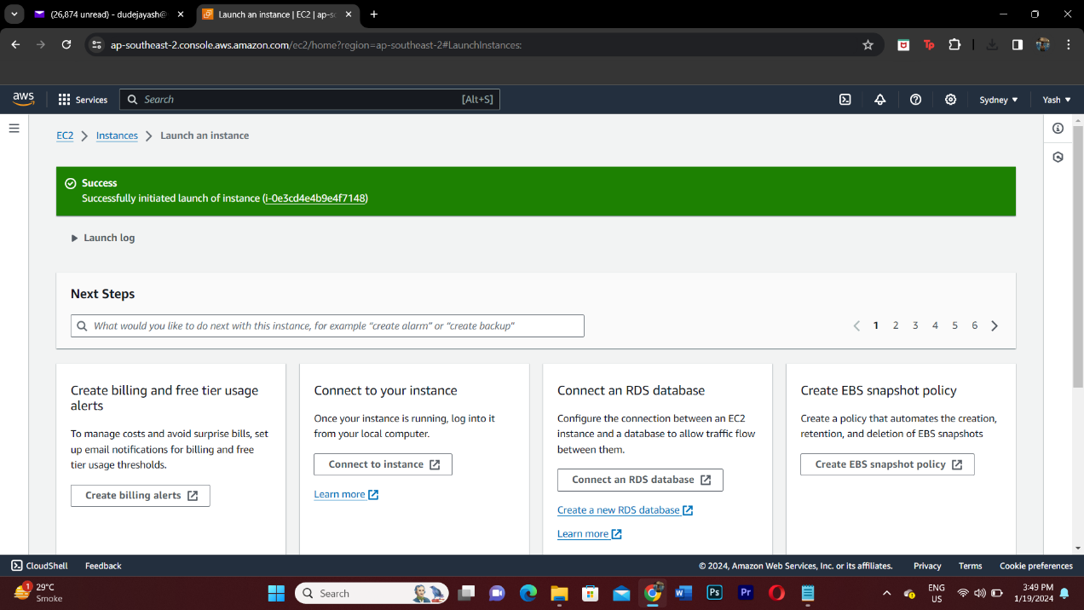

**Step 10: Select the instance and click on connect**

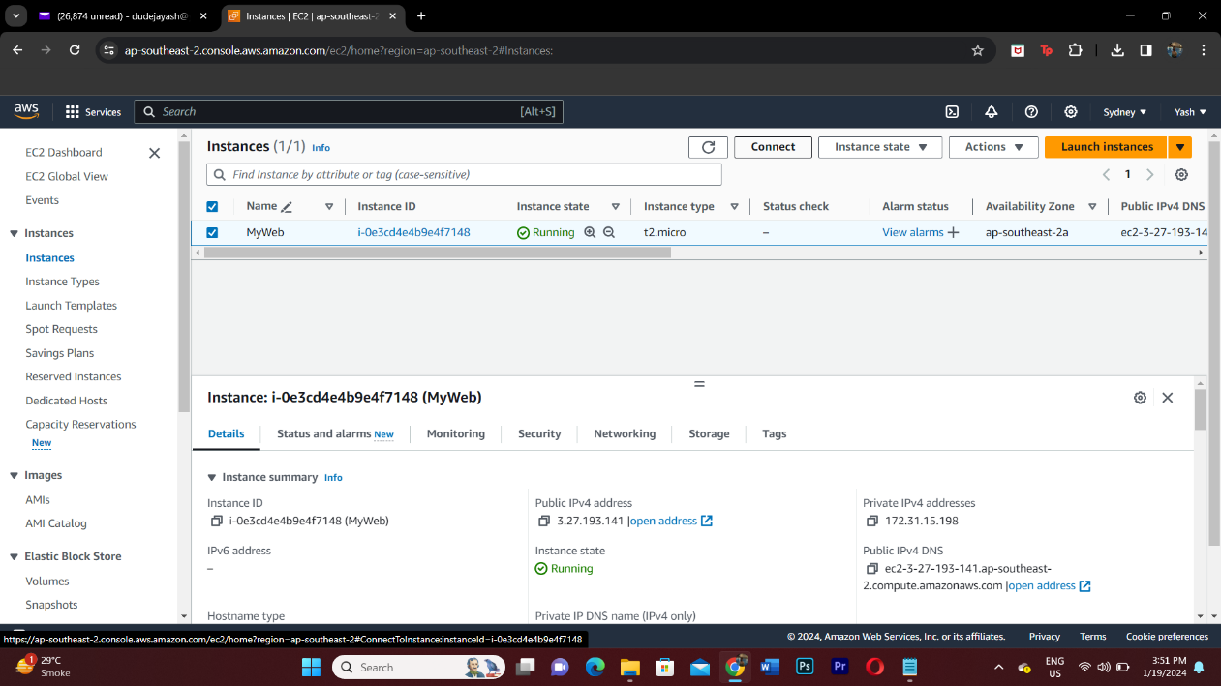

**Step 2: Click on RDP client and download the RDP dile**

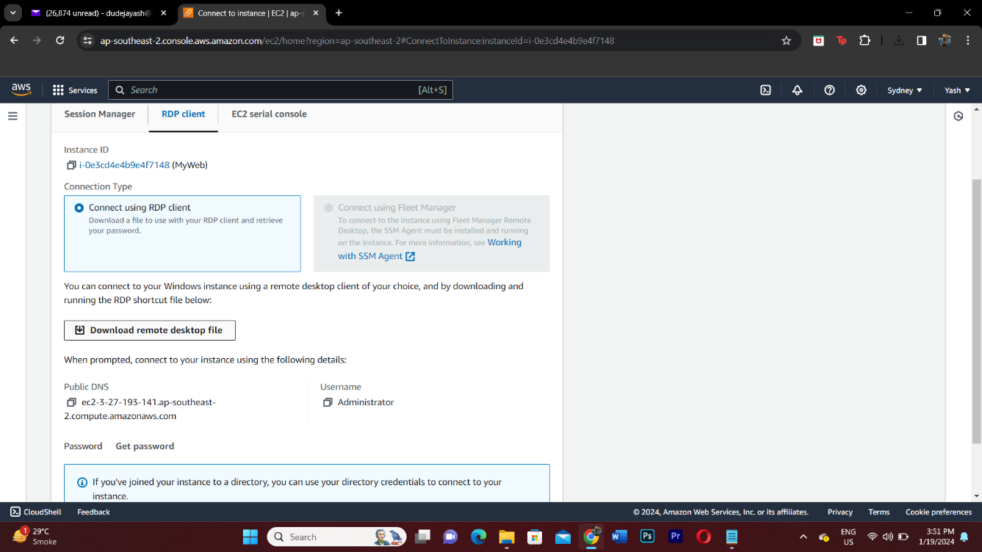

**Step 11: Now click on get password and upload the Key pair value .pem file**

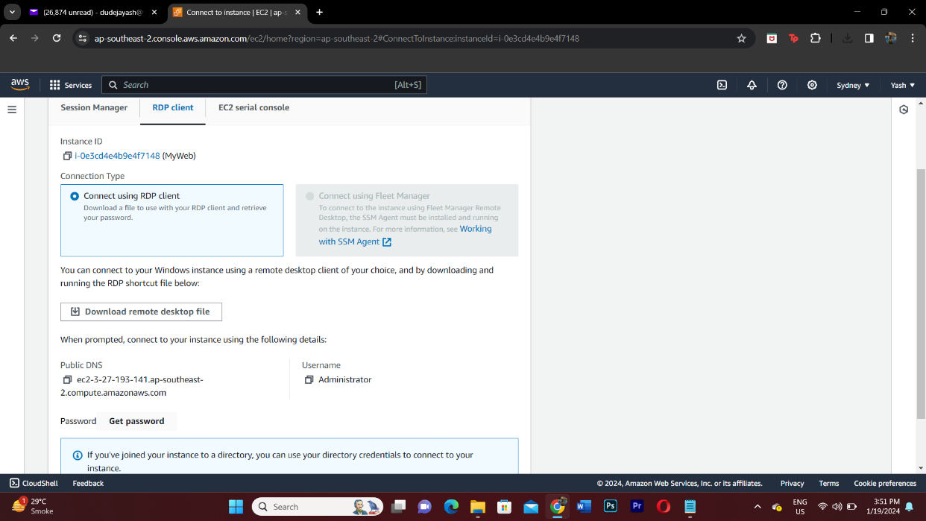

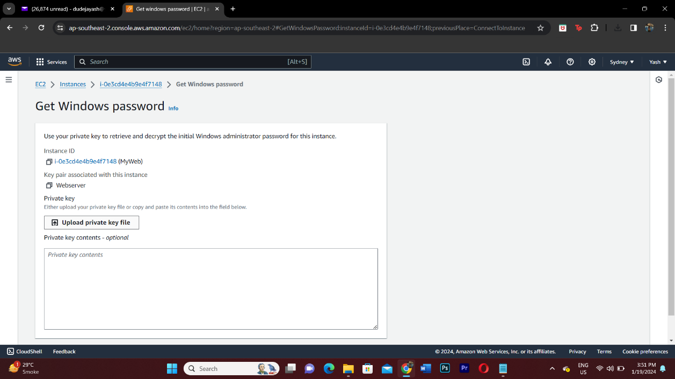

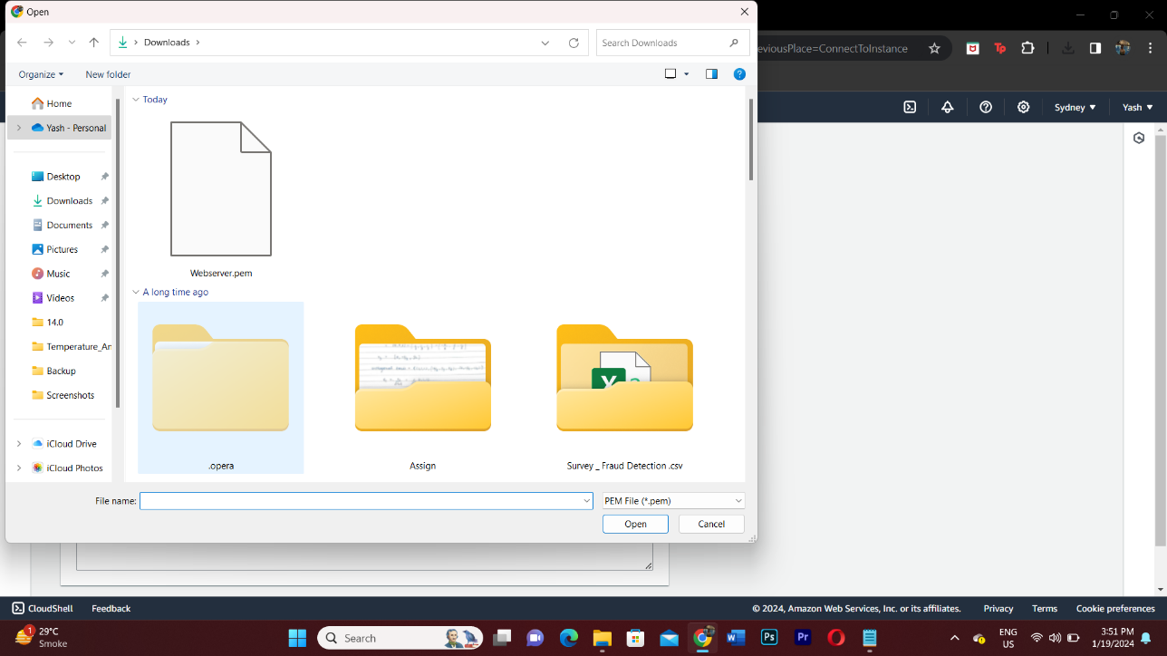

**Step 12: Copy the password**

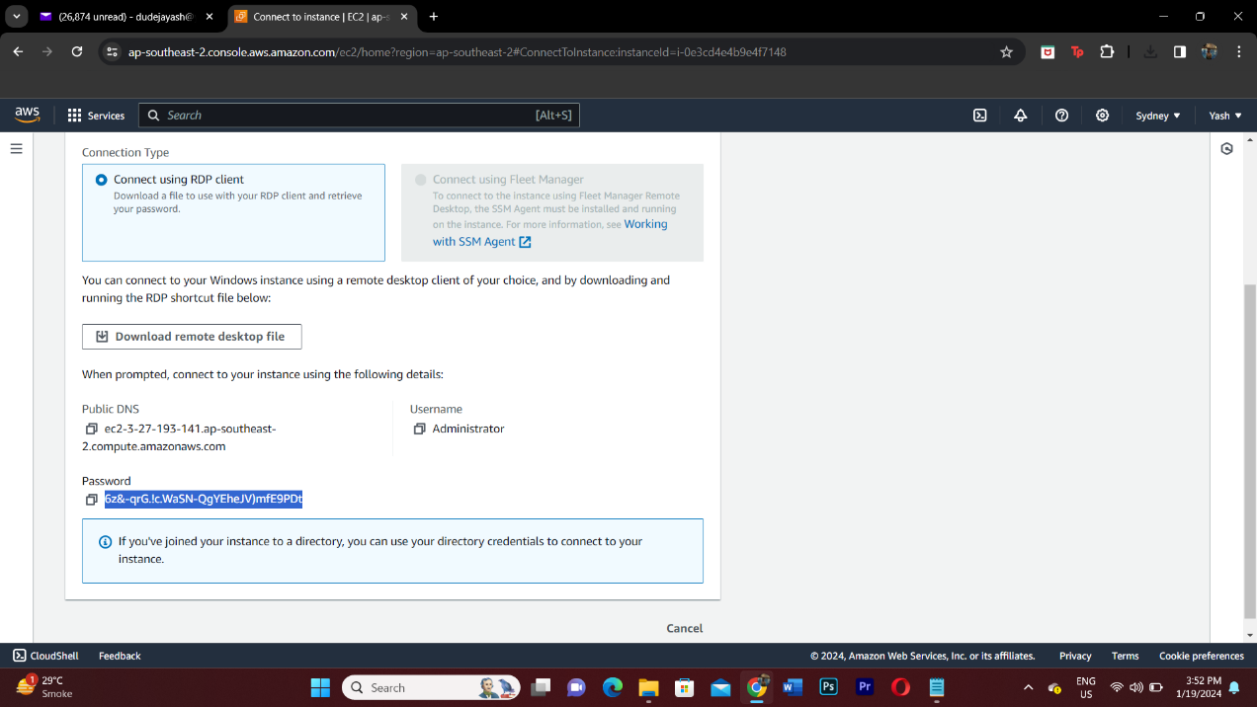

**Step 13: Enter the password to login onto your RDP**

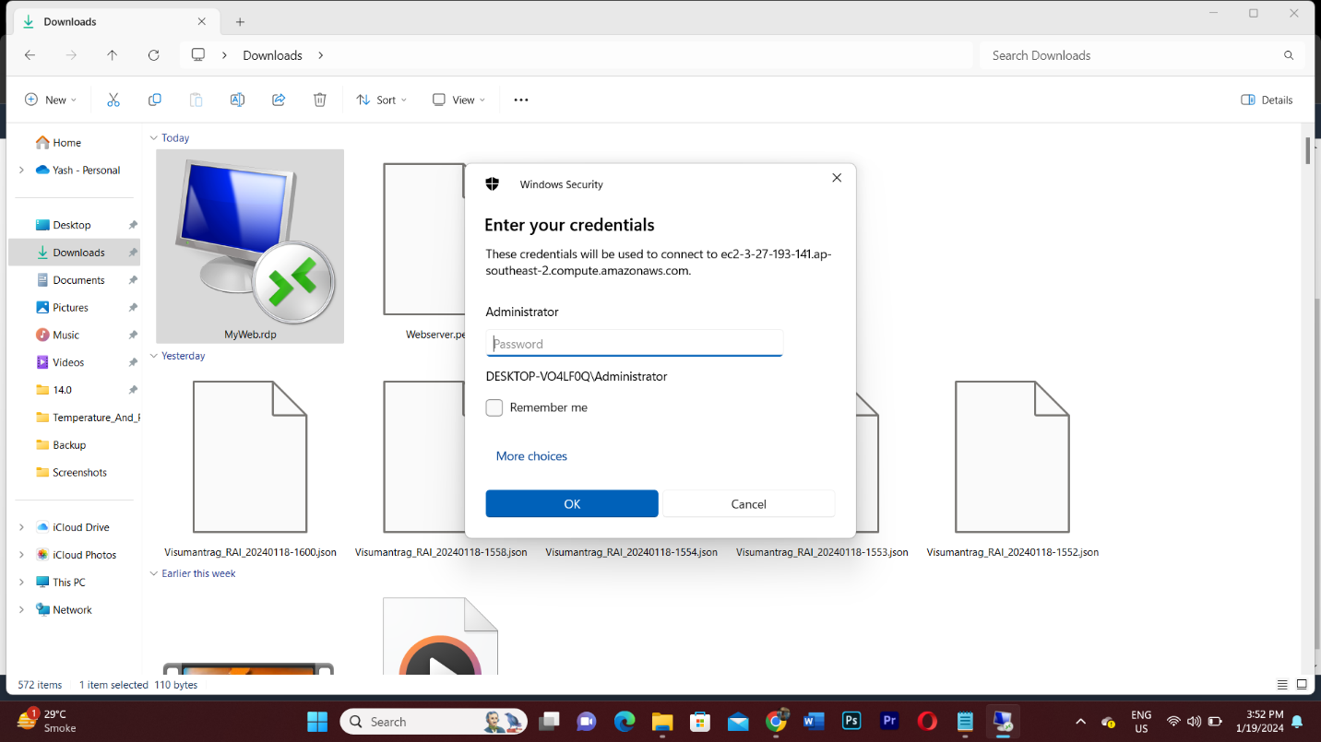

**Step 13: Final output**

